Task 1 : Write a query which uses join and let us know the internal processing of the query.
Query:- select student.s_name ,marks.score,details.school_id from student inner join marks on student.s_id=marks.s_id inner join details on details.school_id=marks.school_id where student.s_id=3;
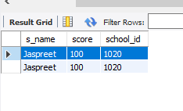
Order of Execution:-
Parsing
Step 1 :- Syntax Check
Step 2 :- Semantic Check
Step 3 :- Shared Pool Check
Step 4 :- Code Optimization
Step 5 :- Row Source Generation
Step 6 :- Execution
Order of Execution with Referance of above Query:
Step 1- From Clause Should get executed first to list the table and also person join on tables.
Query:- select student.s_name ,marks.score,details.school_id from student inner join marks on student.s_id=marks.s_id inner join details on details.school_id=marks.school_id where student.s_id=3;
Step 2- Where Clause executed after from clause to filter data on given condition .
Query:- select student.s_name ,marks.score,details.school_id from student inner join marks on student.s_id=marks.s_id inner join details on details.school_id=marks.school_id where student.s_id=3;
Step 3- Suppose we also have Group by in our query then after the where clause group by executed after where clause.
Query:- select student.s_name ,marks.score,details.school_id from student inner join marks on student.s_id=marks.s_id inner join details on details.school_id=marks.school_id Group by s_name;
Step 4- After Group by the Having which is like where clause but it get executed after the group By clause.
Step 5- After all this execution the Select statement get executed to display the output of query we can also define limited column which we want to display.
Step 6- At last Order by get executed to set the Order of output data in Asecending or Descending form.
Query:- select student.s_name ,marks.score,details.school_id from student inner join marks on student.s_id=marks.s_id inner join details on details.school_id=marks.school_id order by s_name;

Task 2 :- Write a query to calculate the age based on the date of birth value given in the column.
Table Creation:- create table user (name varchar(20), dob date);
insert into user values("Vinod",19990331),("Satish",19970212),("Arush",19950331);
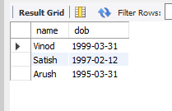
Query to Calculate Age:-
SELECT name , DATE_FORMAT(FROM_DAYS(DATEDIFF(now(),dob)), '%Y')+0 AS Age from user ;
